Quarterly Meeting
Thursday, January 18, 2024
Westminster Presbyterian Church
1438 Sheridan Rd
Social Hour: 7:00 -7:30pm
Meeting: 7:30 - 9:00pm

Our next quarterly meeting will be in-person at the Westminster Presbyterian Church at 7:30 PM on Thursday, January 18. The agenda for this meeting will include:

Meet Sergeant Carlai Moore - Community Engagement Office with Brookhaven Police Department. Sergeant Moore leads the new team patrolling our neighborhood. She is a six-year veteran of the Brookhaven Police department, who in 2020, was named a “Wonder Woman” of the year by Best Self Atlanta magazine. Sergeant Moore will explain the new team’s activities and introduce the other members. They will be patrolling all of the nearly 30 streets that make up our neighborhood - both within and beyond the city limits.

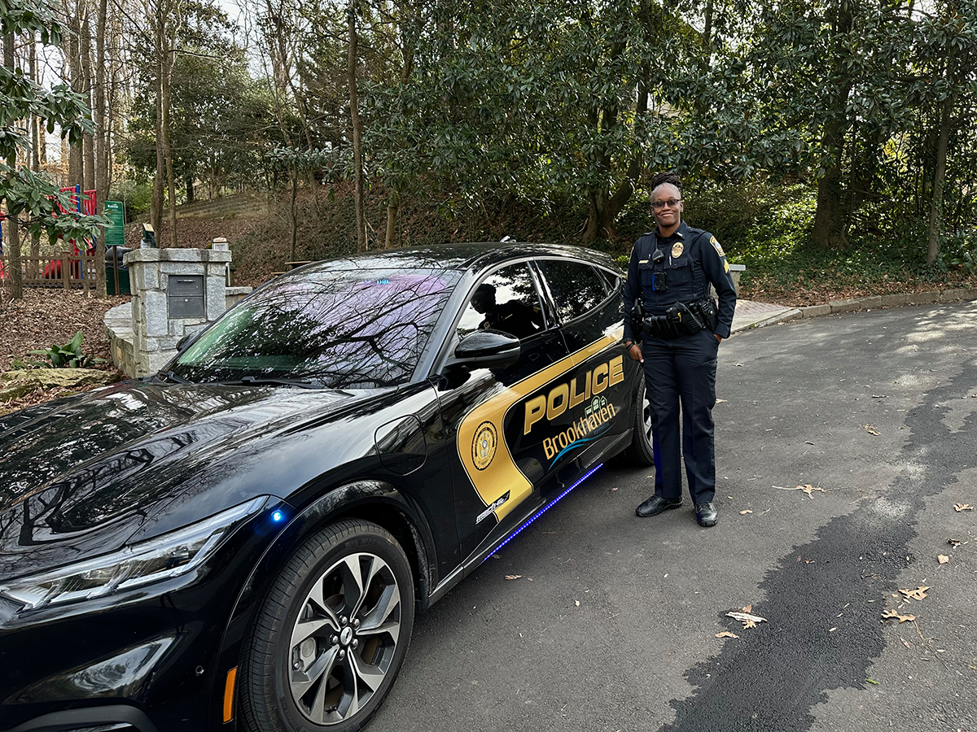

Update on Peachtree Dekalb Airport expansion. LVPCA member Julie Donovan will report on a proposal to expand the ground facilities at PDK airport and tell us about concerns expressed by residents of nearby neighborhoods.

Update on roads, bridges and paths. Did you know the City of Brookhaven is planning not one, but two bridges across I-85 (one for cars, one for pedestrians) to connect our neighborhood with the Buford Highway commercial district, the Peachtree Creek Greenway, and ultimately the Atlanta Beltline? And that DeKalb County (with help from MARTA) may finally build out sidewalks on areas of Briarcliff Road where they are lacking? And that an end may be in sight for the GDOT project at the intersection of Briarcliff and LaVista Roads? We’ll present an update and discuss formation of a task force to monitor neighborhood impacts.

Updates from the LVPCA Board members on zoning, financials and crime statistics (time permitting).

visit lavistapark.org

